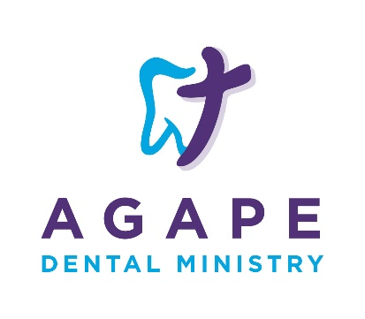
Volunteer Release and Waiver of Liability

This Volunteer Release and Waiver of Liability executed on ______________ (Date) by ___________________________________(Volunteer) releases Agape Dental Ministry, a 501(c)(3) nonprofit corporation organized and existing under the laws of the State of North Carolina and each of its directors, managers, dental professionals, volunteers and business associates, of any liability.

The volunteer desires to provide volunteer services for Agape Dental Ministry and engage in activities related to serving as a volunteer including, but not limited to duties related to the position of ____________________________________________(List position)Volunteer understands that the scope of the volunteer’s relationship with Agape Dental Ministry is limited to a volunteer position and that no compensation is expected in return for services provided by the volunteer; that Agape Dental Ministry will not provide any benefits traditionally associated with employment to Volunteer; and that Volunteer is responsible for his/her own insurance coverage in the event of personal injury or illness as a result of Volunteer’s services to Agape Dental Ministry.

- Waiver and Release: I, the Volunteer, release and forever discharge and hold harmless Agape Dental Ministry and its successors and assigns from any and all liability, claims and demands of whatever kind or nature, either in law or in equity, which arise or may hereafter arise from the services I provide to Agape Dental Ministry. I understand and acknowledge that this Release discharges Agape Dental Ministry from any liability or claim that I may have against Agape Dental Ministry with respect to bodily injury, personal injury, illness, death, or property damage that may result from the services I provide to Agape Dental Ministry or occurring while I am providing volunteer services.
- Insurance: Further I understand that Agape Dental Ministry does not assume any responsibility for or obligation to provide me with financial or other assistance, including but not limited to medical, health or disability benefits or insurance of any nature in the event of my injury, illness, death or damage to my property. I expressly waive any such claim for compensation or liability on the part of Agape Dental Ministry beyond what may be offered freely by Agape Dental Ministry in the event of such injury or medical expenses incurred by me.
- Medical Treatment: I hereby release and forever discharge Agape Dental Ministry from any claim whatsoever which arises or may hereafter arise on account of any first-aid treatment or other medical services rendered in connection with an emergency during my tenure as a volunteer with Agape Dental Ministry.
- Assumption of Risk: I understand that the services I provide to Agape Dental Ministry may include activities that may be hazardous to me or indirectly expose me to hazards including, but not limited to: Exposure to infectious disease agents or biologically contaminated materials, exposure to sharp objects, exposure to toxic chemicals, exposure to x-rays, exposure to hostile clients or area residents, exposure to possible wet floors and risk associated with repetitive motion. As a volunteer, I hereby expressly assume the risk of injury or harm from these activities and others not expressly mentioned and release Agape Dental Ministry from all liability for injury, illness, death or property damage resulting from the services I provide as a volunteer or occurring while I am providing volunteer services or on site.
- Photographic Release: I grant and convey to agape Dental Ministry all right, title, and interests in any and all photographs, images, video, or audio recordings of me or my likeness or voice made by Agape Dental Ministry in connection with my providing volunteer services to Agape Dental Ministry.
- Other: As a volunteer, I expressly agree that this Release in intended to be as broad and inclusive as permitted by the laws of the State of North Carolina and that this Release shall be governed by and interpreted in accordance with the laws of the State of North Carolina. I agree that in the event that any clause or provision of this Release is deemed invalid, the enforceability of the remaining provisions of the Release shall not be affected.

By signing below, I express my understanding and intent to enter into this Release and Waiver of Liability willingly and voluntarily.

Signature_______________________________________Date__________________

Witness________________________________________Date___________________

