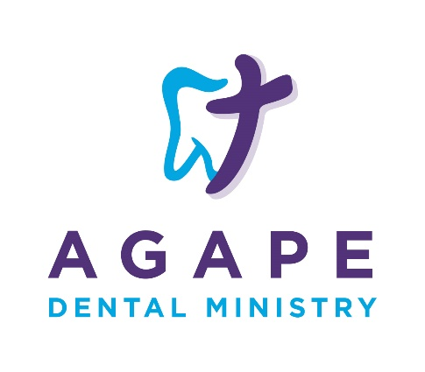
Photo Release

I _____________________________________ hereby authorize Agape Dental Ministry, its representatives, and employees the rights of my image, likeness and sound of my voice as recorded by photograph, audio or video means. I understand that this will become property of Agape Dental Ministry and I am not entitled to any payment. I also waive any right to inspect or approve any photo or video taken for use.

In so allowing any photo, video or audio recording may be used for, but not limited to, publicity, advertising, fund raising, social media, and education. I also understand that there is no time limit to the use of the aforementioned.

I acknowledge that I have read and understand the above release.

Name (printed):____________________________________________

Signature:_________________________________________________

Date:_____________________________________________________

Financial information about this organization and a copy of its license are available from the State Solicitation Licensing Branch at 1-888-830-4989 or 1-919-827-2214

